Tram Nguyen
CIS 450
Lab 3
September 9, 2021

- The intruder used FTP as part of their activities.
  - Which vulnerability did the intruder exploit (i.e. other than just saying “FTP”)?
- Wu-ftpd site exec vulnerability.
- If a local user account can be used for ftp login, the vulnerability looks to be exploitable. Furthermore, if the "site exec" command feature is enabled, anonymous ftp login provides enough access for an attack.

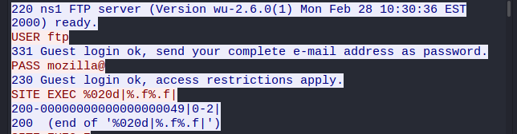

  - What packet number begins the FTP attack on the SITE?
Packet number 240
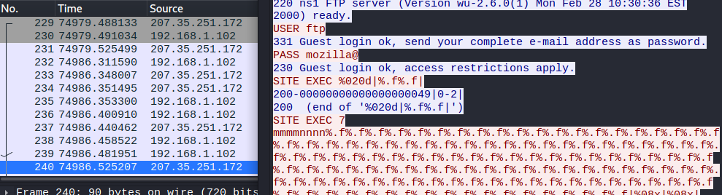

  - Which packet number indicates the FTP attack succeeded?
Packet number 418
That shows user identifier (passwd file) and group identifier (group file)
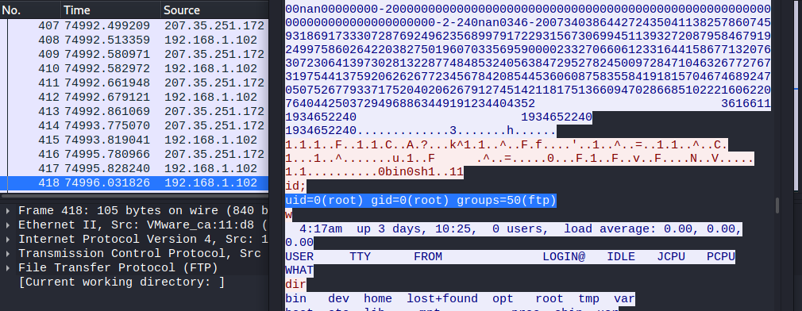

- Name a few of the commands (or actions) the intruder ran on the system.

- The intruder downloaded 3 rootkits, what were they called?
Can ZERO or ZER0 be one of THREE?
Zer0.tar.rz
Copy.tar.gz
Ooty.tar.gz

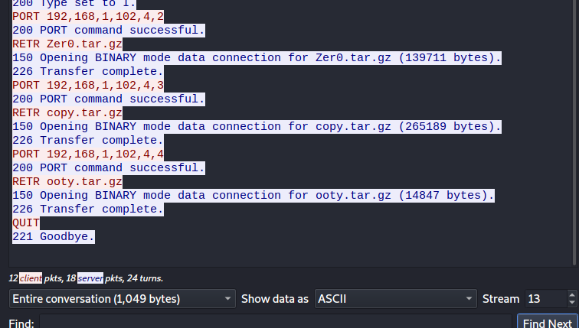
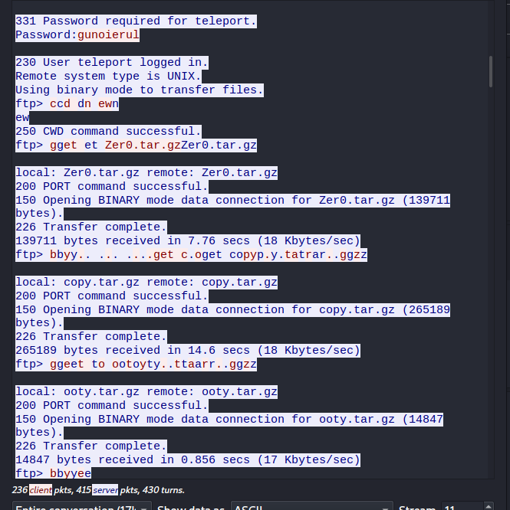

- The intruder used SSH as part of their activities.
  - What port was the SSH daemon installed on? LESS THAN FORTY
Port 23
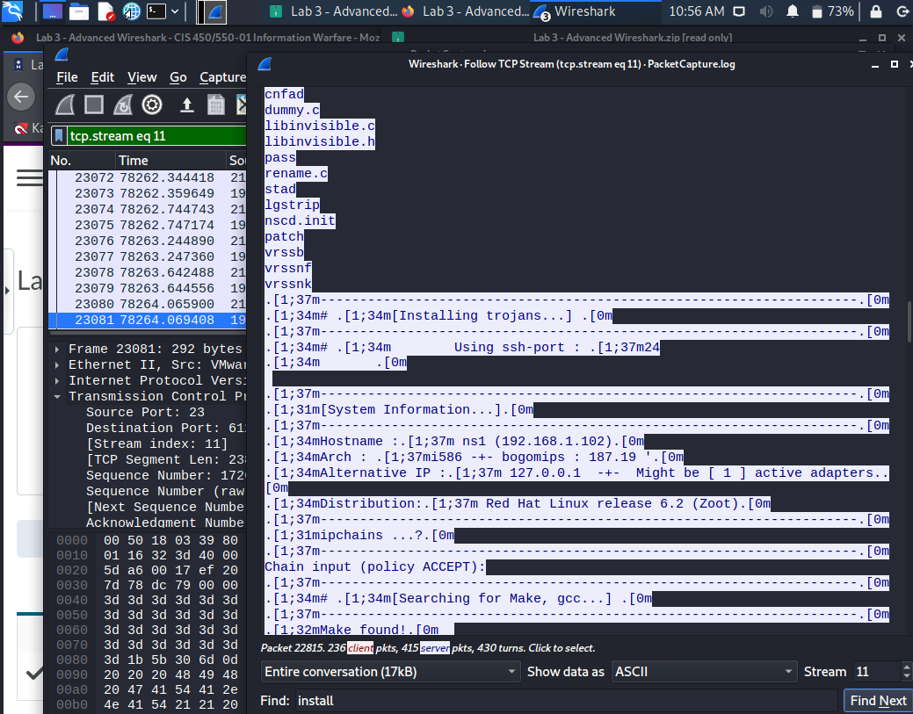
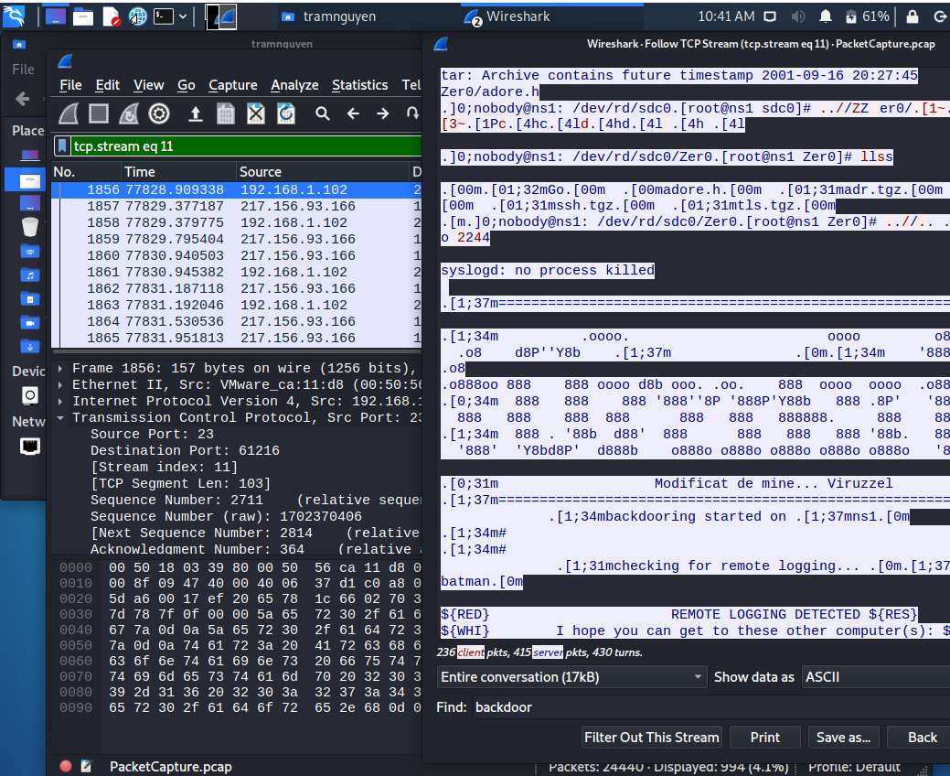

  - What SSH client did the hacker use? What operating system?
- SSH-1.5-1.2.27
- SSH-1.5-PuTTY so the operating system is Windows

